DATA ANALYTICS
PYTHON ASSIGNMENT 2 :DATA STRUCTURES- LIST, DICTIONARY, SET & CONDITIONAL STATEMENTS
SUBMISSION:03.10.2026
NAME : DURGADEVI V

Data Structures - List, Dictionary, Set & Conditional Statements

List (Creation, Modification and Access):

1. List Creation:

Task:

a. Create a list named age_list with five integer elements. For eg., [24, 25, 26, 27, 28]
b. Create a list named name_list with five string elements.

Solution :

Preview screenshot :
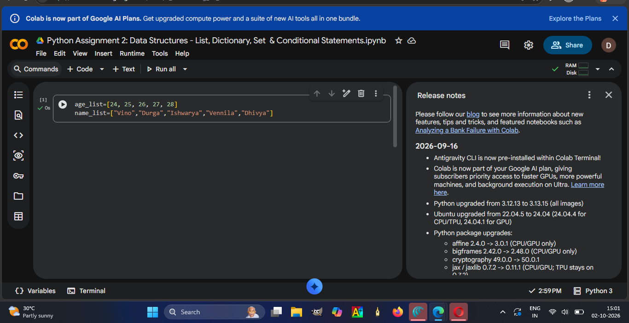

Explanation:
- First 1 had created the list with five integer elements and named the list as age_list.
- Then created the name_list with five string elements.
- The above mentioned screenshot represents the result.

2. List Operations / Modifications:

Task 1: Append the string "Yazhini" to name_list.

Solution :

Preview screenshot :
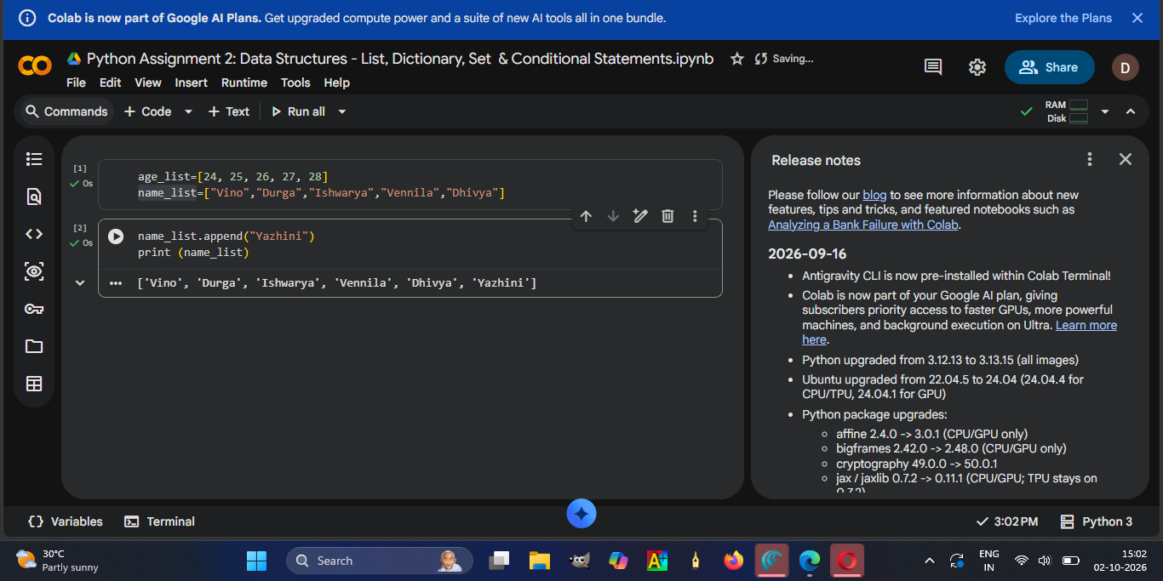
Explanation :
- I had used the append method for adding a string to name_list.
- The above mentioned screenshot represents the result.

Task 2 : Insert the element 30 at index 2 in age_list.

Solution:

Preview screenshot :
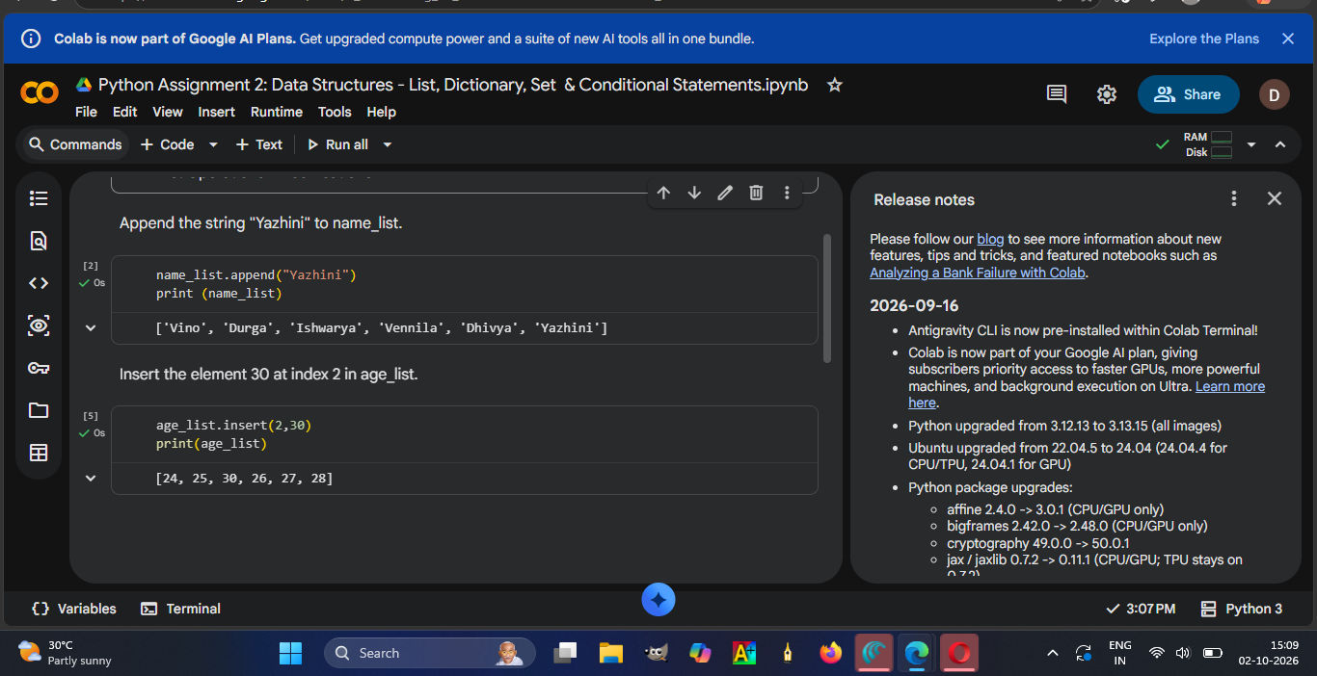

Explanation:
- I had used the insert method for inserting an element into age_list.
- The above mentioned screenshot represents the result.

Task 3: Remove the string "Yazhini" from name_list.

Solution:

Preview screenshot :
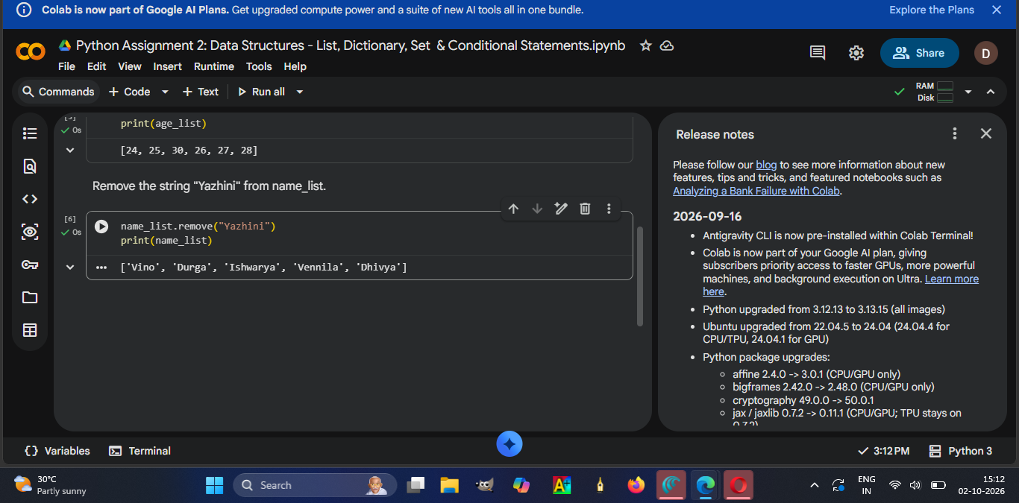

Explanation :

- I had used the insert method for inserting a string into name_list.
- The above mentioned screenshot represents the result.

Task 4: Pop the last element from age_list.

Solution:

Preview screenshot :
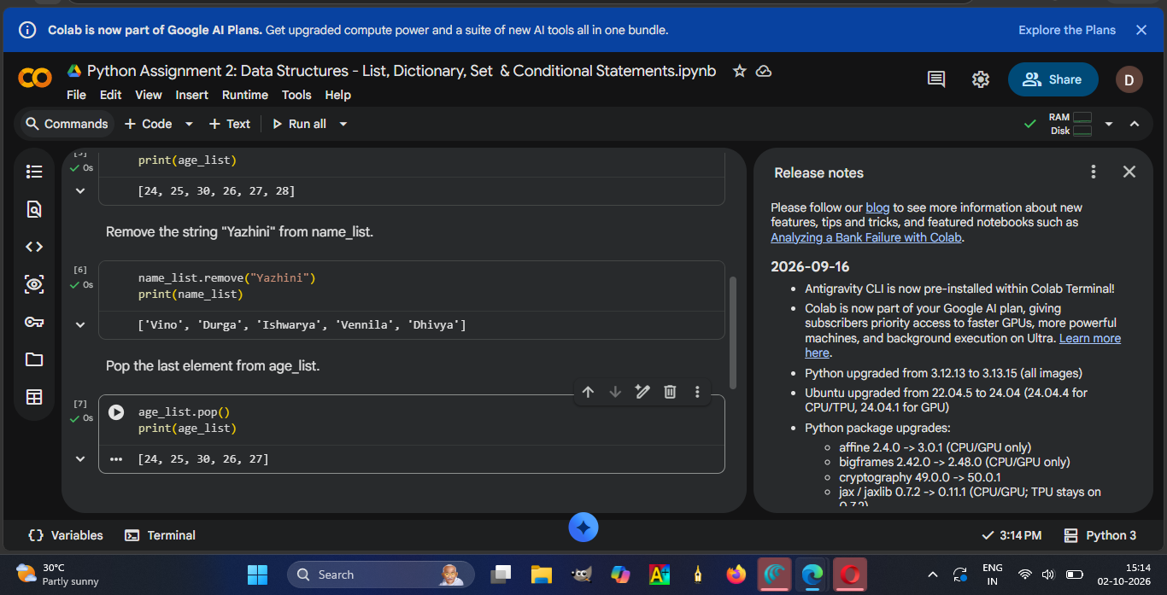

Explanation :
- I had used the pop method for deleting an element into age_list.
- The above mentioned screenshot represents the result.

Task 5 : Extend the age_list with additional ages [29, 30, 26].

Solution :

Preview screenshot :
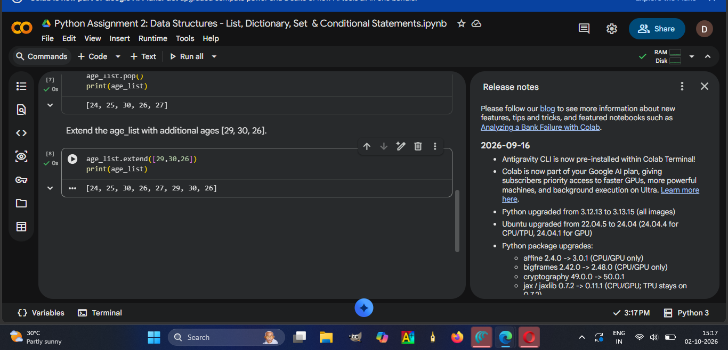

Explanation :
- I had used the extend method to add [29, 30, 26] into age_list.
- The above mentioned screenshot represents the result.

Task 6 : Sort age_list in descending order.

Solution :

Preview screenshot :
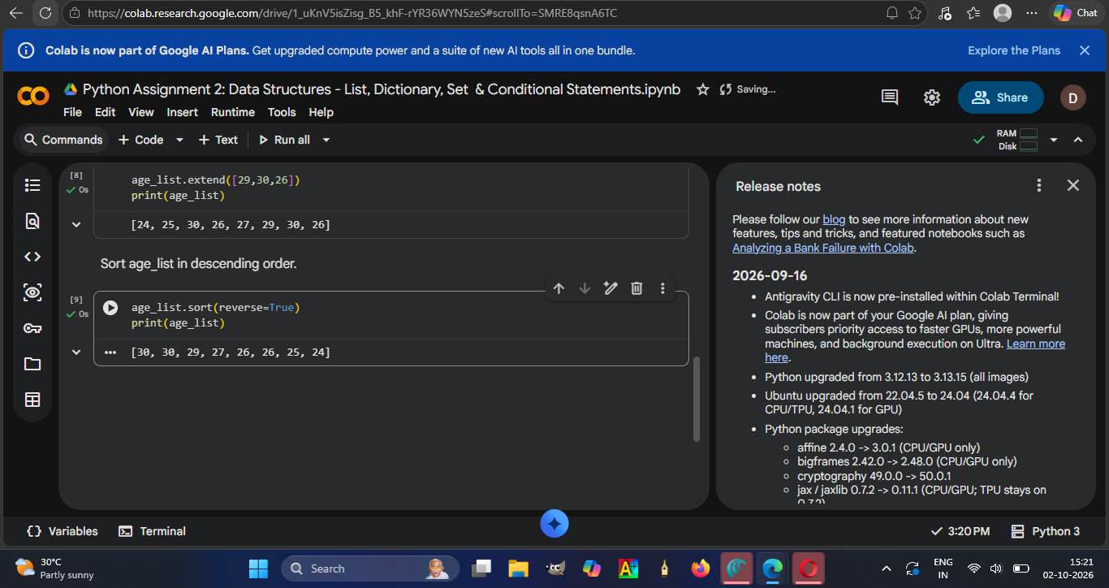

Explanation :
- I had used the sort method to sort age_list with reverse=true so it sorted the age list in descending order.
- The above mentioned screenshot represents the result.

Task 7: Find Max age, Min age and sum of all ages from age_list.

Solution :

Preview screenshot :
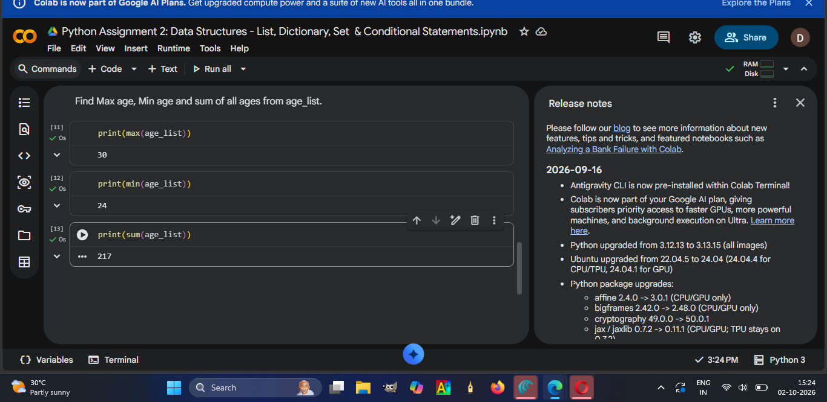

Explanation :
- I had used the max method to find the maximum age from the age_list. And a method to find minimum age from the age_list. And a sum method to find the sum of all ages from age_list.
- The above mentioned screenshot represents the result.

3. Accessing List Elements:

Task 1: Print the first element of name_list.

Solution :

Preview screenshot :
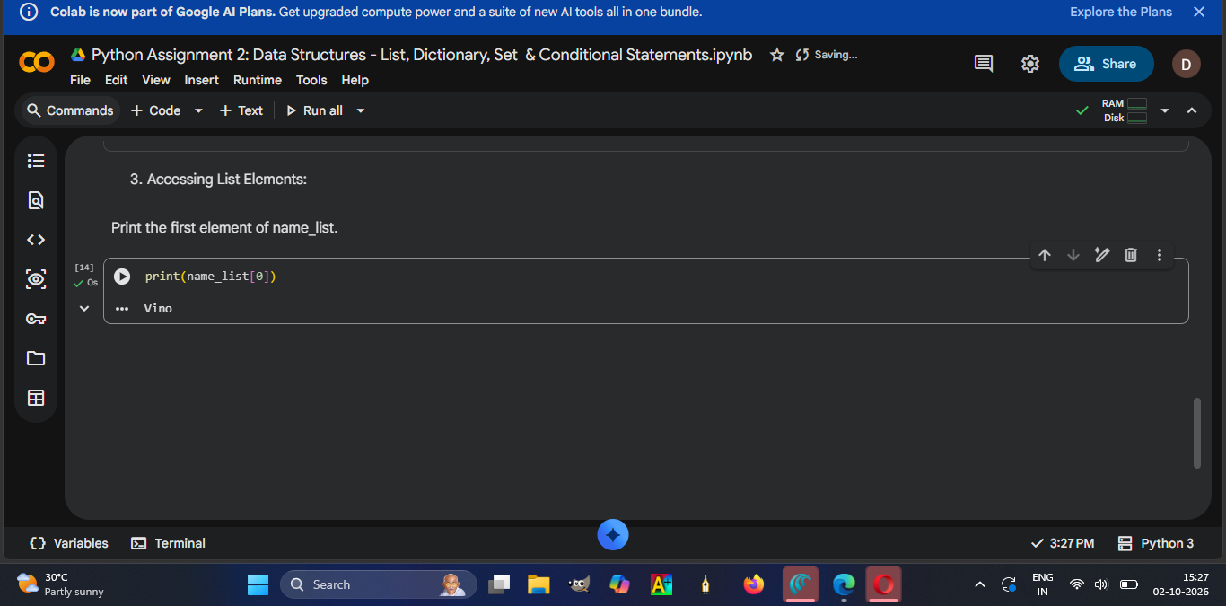

Explanation :
- I had used the indexing method for printing the first element in name_list.
- Here 0 represents the first element in the name_list.
- The above mentioned screenshot represents the result.

Task 2:Print the last element of name_list.

Solution :

Preview screenshot :
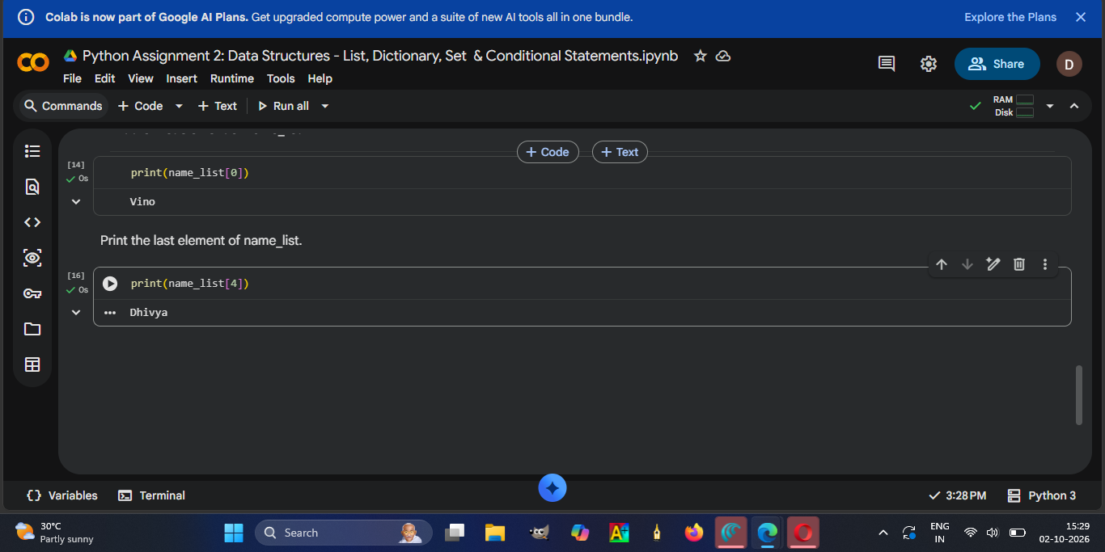

Explanation :
- I had used the indexing method for printing the last element in name_list.
- Here 4 represents the last element in the name_list.
- The above mentioned screenshot represents the result.

Task 3 :Print the elements from index 2 to index 4 in name_list.

Solution :

Preview screenshot :
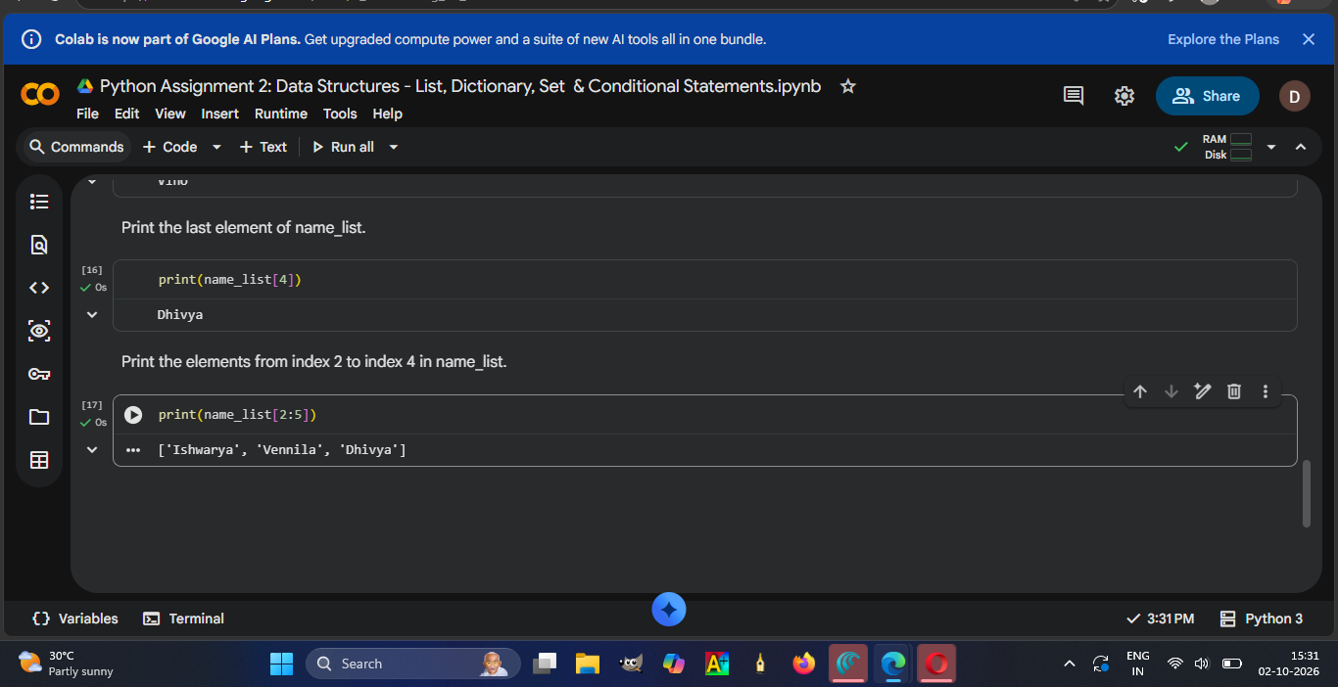

Explanation :
- I had used the slicing method for printing the 2 to 4th element in name_list.
- Here 2 represents the third element 5 represents the last element in the name_list.
- The above mentioned screenshot represents the result.

Task 4: Print the elements of name_list in reverse order.

Solution :

Preview screenshot :
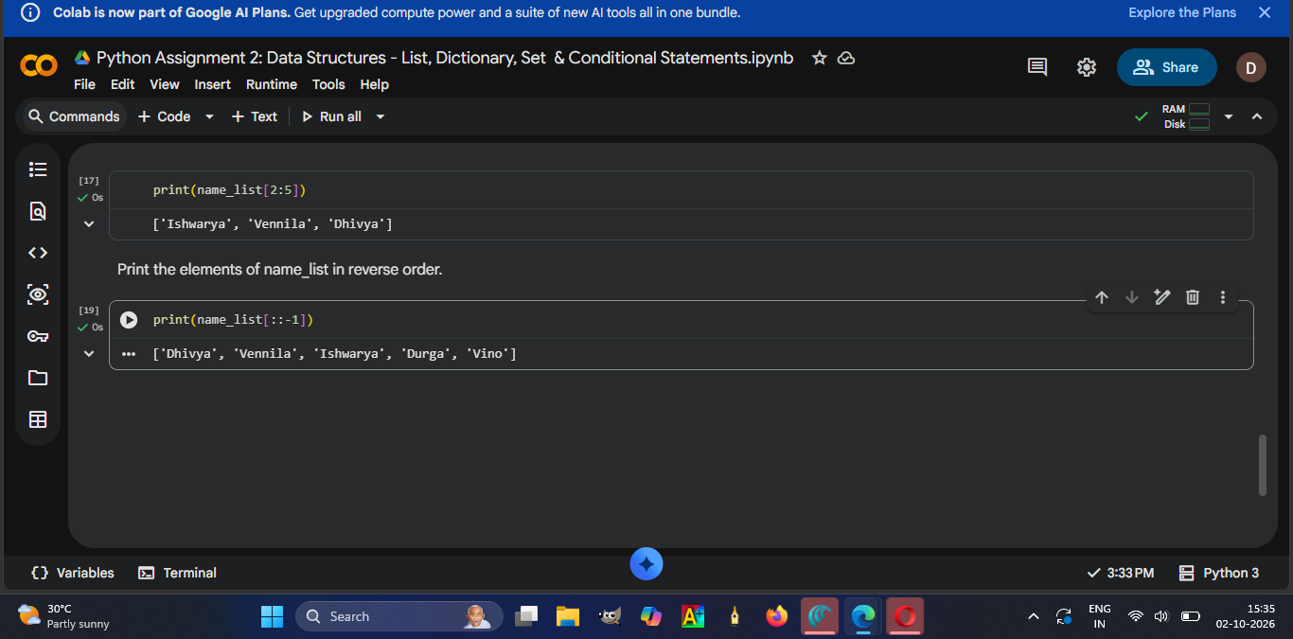

Explanation :
- I had used the slicing method for printing the name_list in reverse order.
- Here ::-1 is used to reverse the name_list.
- The above mentioned screenshot represents the result.

Dictionary (Creation, Modification and Access):

Task 1 : Create a dictionary named student_marks that maps the names of five students to their marks (use scale of from 0 to 100).

Solution :

Preview screenshot :
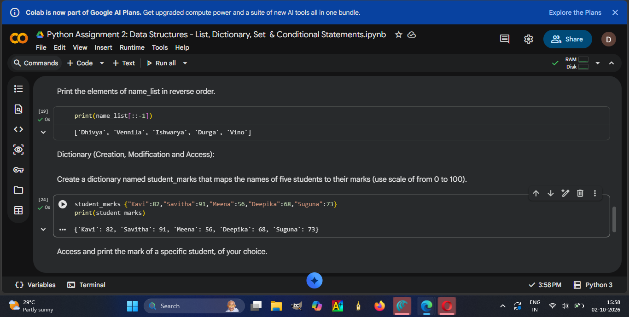

Explanation :
- I had created a dictionary named student_marks.
- Here key value pairs are separated by ’ : ‘ .
- The above mentioned screenshot represents the result.

Task 2: Access and print the mark of a specific student, of your choice.

Solution :

Preview screenshot :
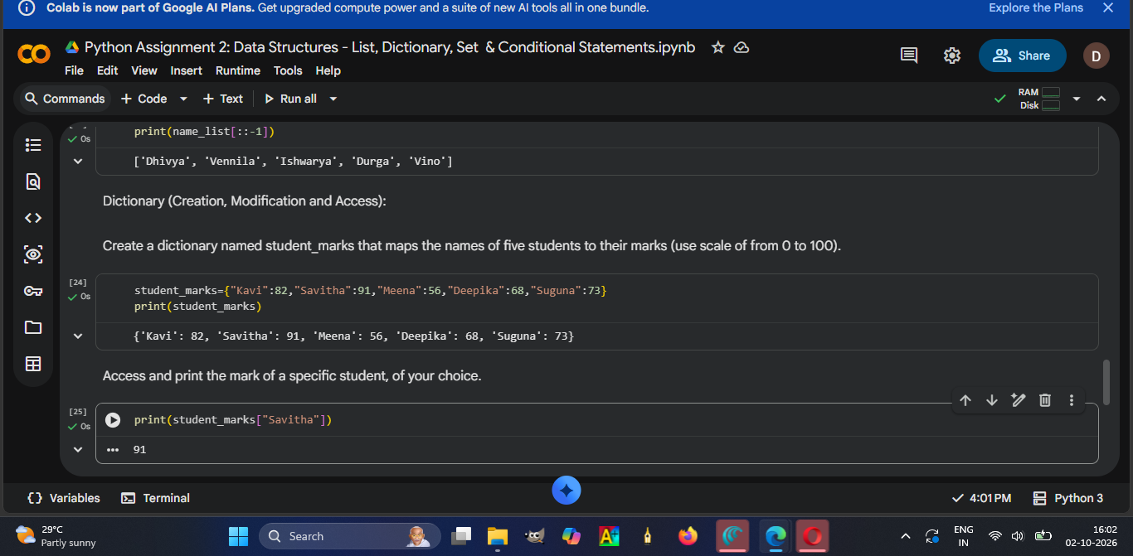

Explanation :
- I had used the key (“Savitha”) to print the value (91) in student_marks.
- Here the student name is key and the mark is a value.
- The above mentioned screenshot represents the result.

Task 3 : Add a new student "Janani" with a mark of 80 to the student_marks dictionary.

Solution :

Preview screenshot :
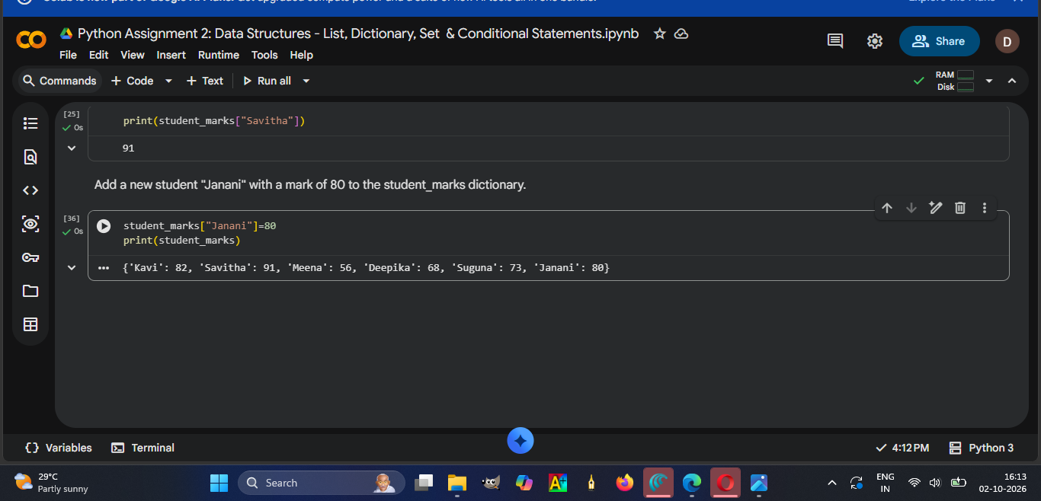

Explanation :
- I had added the student name “Janani” with mark 80 to student_marks.
- The above mentioned screenshot represents the result.

Task 4 : Update the mark of any one older student to 82.

Solution :

Preview screenshot :
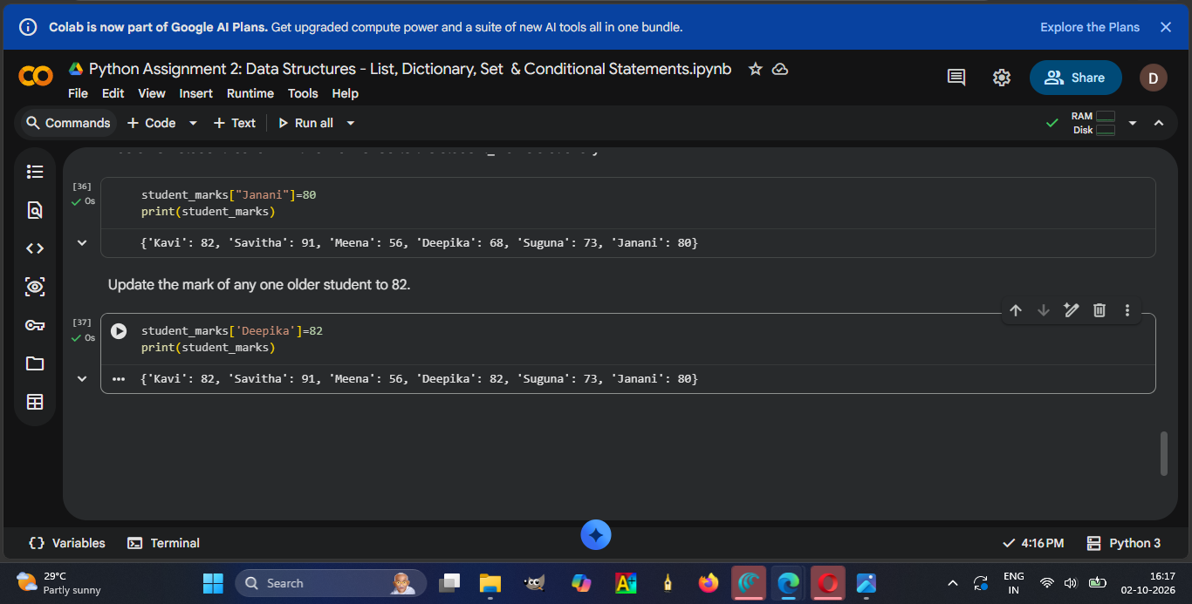

Explanation :
- I had updated the mark 82 to an old student name “Deepika” .
- The above mentioned screenshot represents the result.

Task 5: Use the keys(), values(), and items() methods to print all keys, values, and key-value pairs in the student_marks dictionary.

Solution :

Preview screenshot :
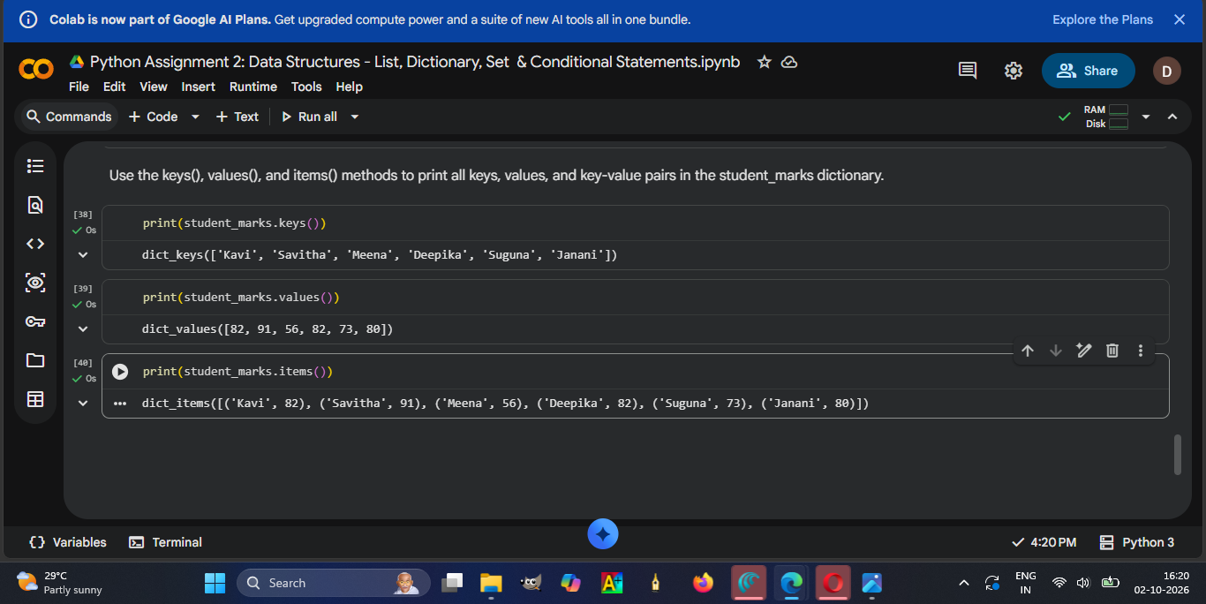

Explanation :
- I had used the key method to print only keys in the student mark dictionary .
- And I had used the values method to print only values in the student mark dictionary.
- And then I used the item method to print key- value pairs in the student mark dictionary.
- The above mentioned screenshot represents the result.

Sets (Operations):

Task 1 :Create a set called my_set with following values: ['a','e','i','o','u','a','a','i'] . Analyse the output and provide explanation for the same.

Solution :

Preview screenshot :
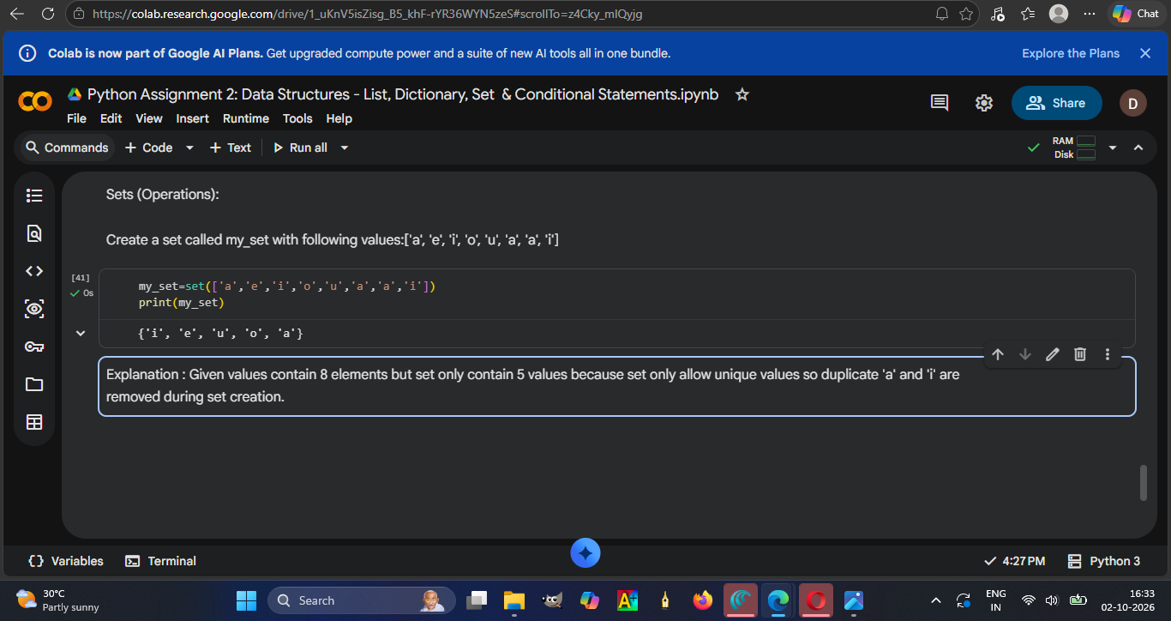

Explanation :
- I had created the set with a given value .
- Given values contain 8 elements but created sets only contain 5 values because sets only allow unique values so duplicates 'a' and 'i' are removed during set creation. .
- The above mentioned screenshot represents the result.

Task 2 :Attempt to change the value of my_set[4] = 's'. If code throws an error, provide an explanation.

Solution :

Preview screenshot :
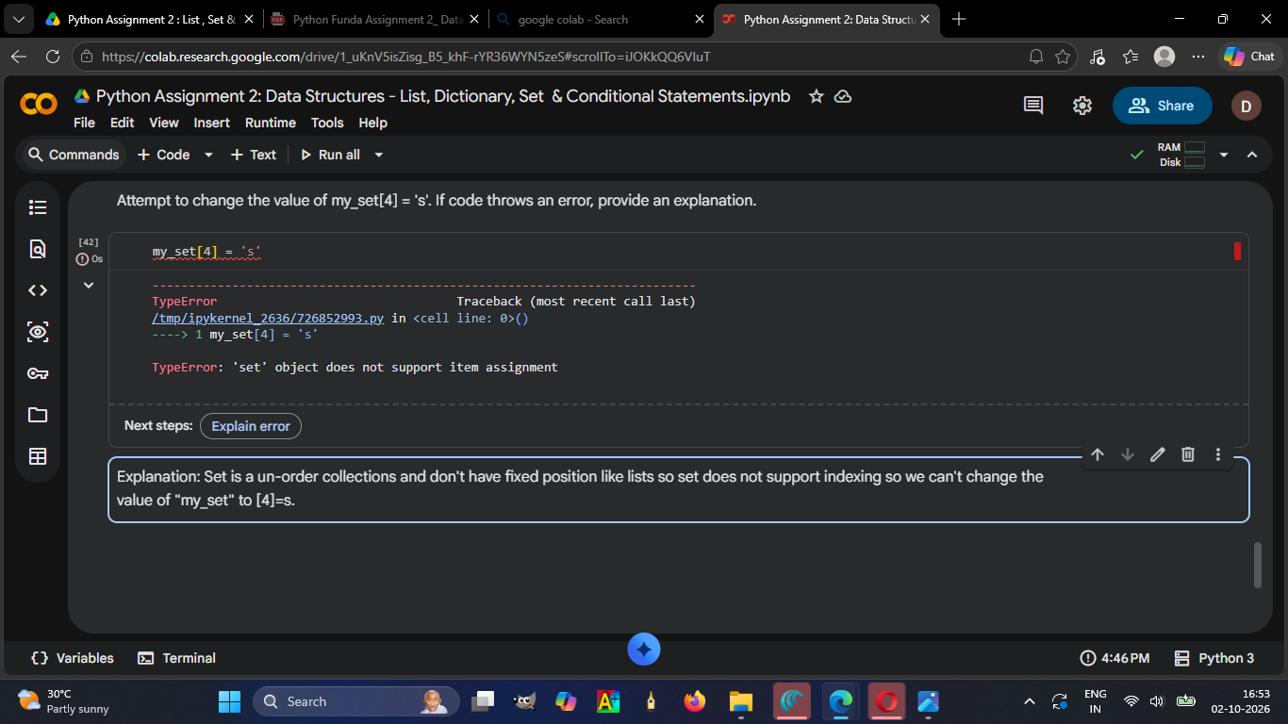

Explanation :
- I had attempted to change the value of my_set[4] but it showed an error because set is an un-order collection and doesn't have fixed position like lists so the set does not support indexing so we can't change the value of "my_set" to [4]=s.
- The above mentioned screenshot represents the result.

Task 3 : Create two sets: set1 with values: {1, 3, 5, 7, 9} , set2 with values: {2, 3, 5, 8, 10}

Solution:

Preview screenshot :
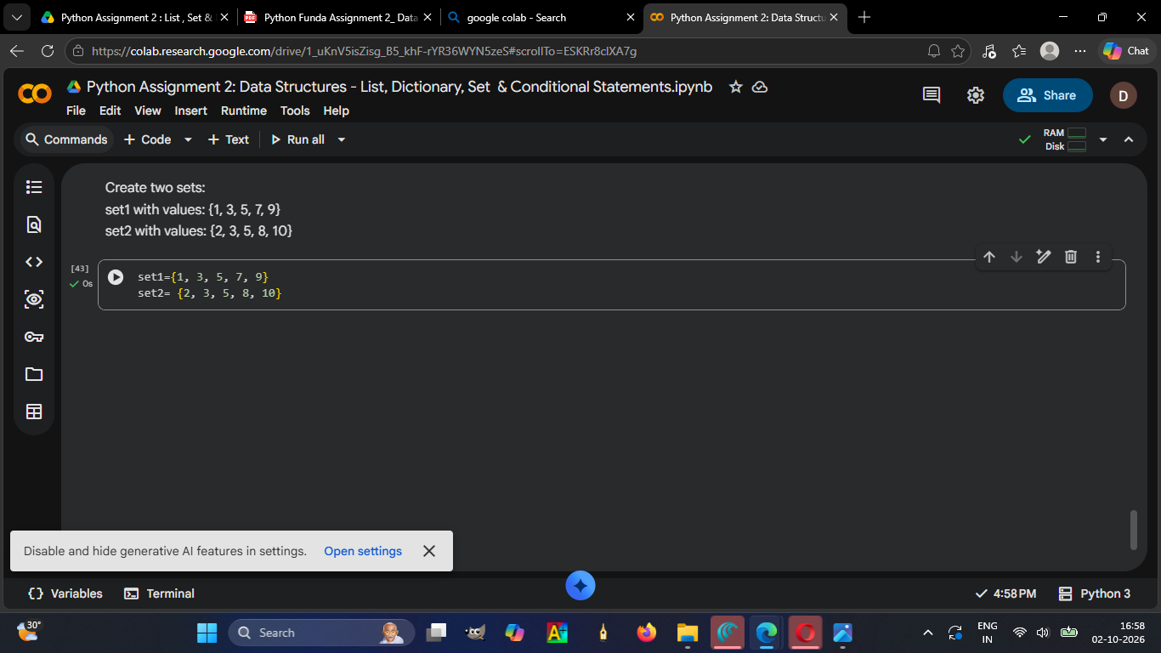
Explanation :
- I had created the two sets named set1 and set2 with the given values.
- The above mentioned screenshot represents the result.

Task 4 : Compute and print the union and intersection of set1 and set2.

Solution:

Preview screenshot :
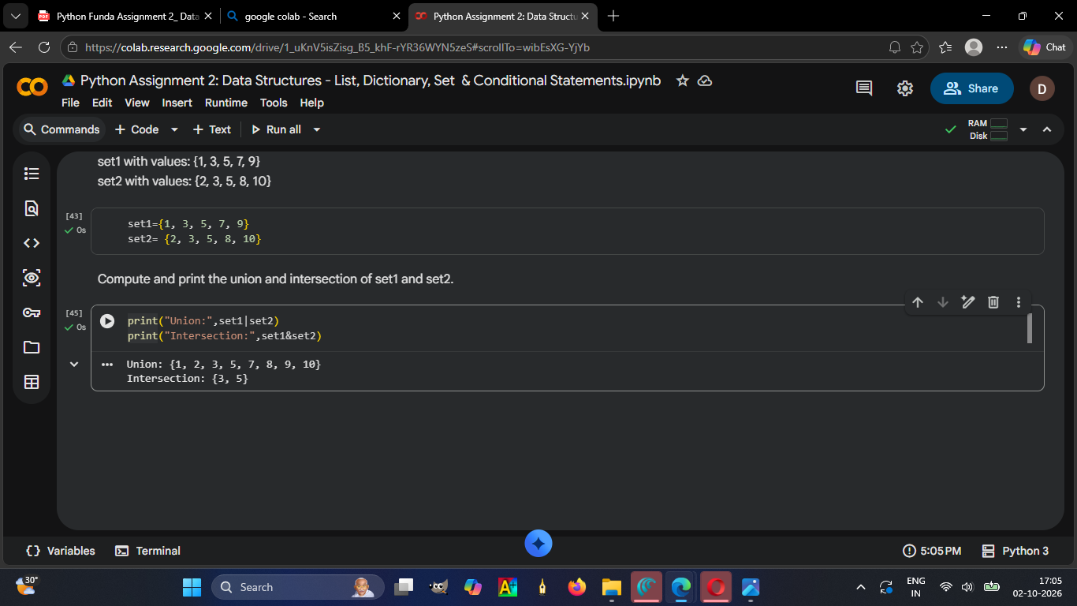

Explanation :
- I had used the “|” symbol for performing union and “&” symbol for performing intersection with set1 and set2 .
- The above mentioned screenshot represents the result.

Operators & Conditional Statements : (IF, ELIF, ELSE)

Task :Write Performance Category Program:

Solution :
Preview screenshot :
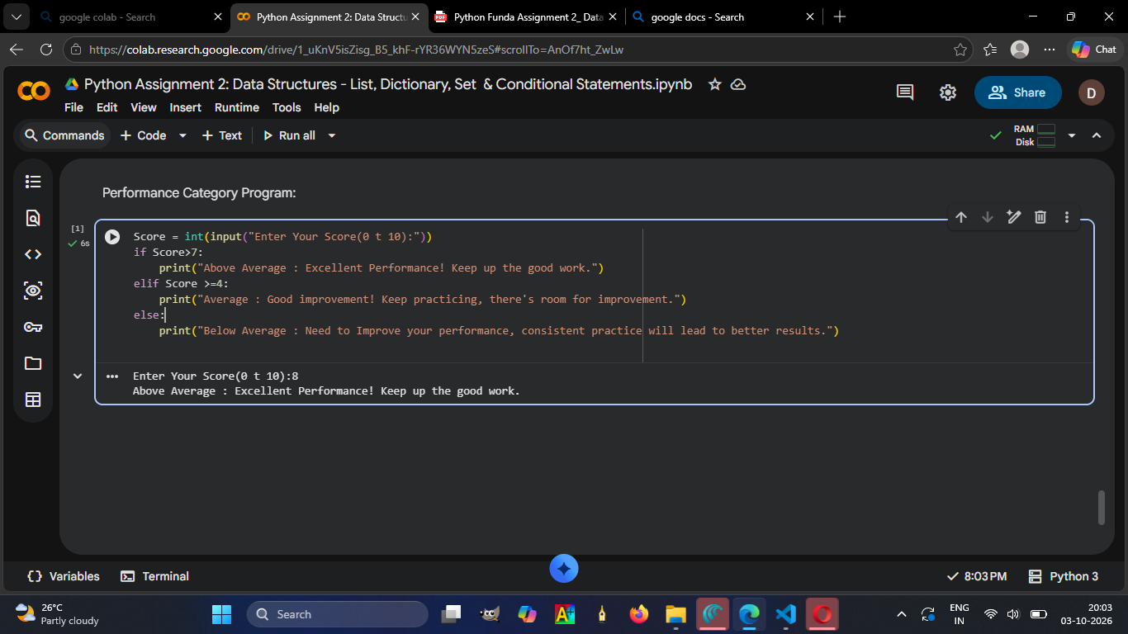

Explanation :
- I had created the nested conditional statement for the performance category program.
- First it will ask the input score with a message that “The score range should be from 0 to 10 : “.
- Then it will run the if and compare the input with a condition greater than 7 .
- If the score is greater then 7 the print the result as “Above Average : Excellent Performance! Keep up the good work."
- If the score is not greater than 7, and it is greater than or equal to 4 ,it prints the result as "Average : Good improvement! Keep practicing, there's room for improvement."
- If the score is less than 4 then it will print the result as "Below Average : Need to Improve your performance, consistent practice will lead to better results."
- The above mentioned screenshot represents the result.

